TDD USING JUNIT5 AND MOCKITO

JUNIT BASIC TESTING EXERCISES:

EXERCISE 1:Setting Up JUnit
Code:
pom.xml
<?xml version="1.0" encoding="UTF-8"?>
<project xmlns="http://maven.apache.org/POM/4.0.0"
xmlns:xsi="http://www.w3.org/2001/XMLSchema-instance"
xsi:schemaLocation="http://maven.apache.org/POM/4.0.0
http://maven.apache.org/xsd/maven-4.0.0.xsd">
<modelVersion>4.0.0</modelVersion>

<groupId>com.example</groupId>
<artifactId>junit-setup-example</artifactId>
<version>1.0-SNAPSHOT</version>

<properties>
<maven.compiler.source>11</maven.compiler.source>
<maven.compiler.target>11</maven.compiler.target>
</properties>

<dependencies>
<!-- JUnit 4 dependency -->
<dependency>
<groupId>junit</groupId>
<artifactId>junit</artifactId>
<version>4.13.2</version>
<scope>test</scope>
</dependency>
</dependencies>
</project>

Calculator.java
package com.example;

public class Calculator {

public int add(int a, int b) {
return a + b;
}

public int subtract(int a, int b) {
return a - b;
}

public int multiply(int a, int b) {
return a * b;
}

public int divide(int a, int b) {
if (b == 0) {
throw new IllegalArgumentException("Cannot divide by zero");
}
return a / b;
}
}

CalculatorTest.java
package com.example;

import org.junit.Test;
import org.junit.Before;
import org.junit.After;
import static org.junit.Assert.*;

public class CalculatorTest {

private Calculator calculator;

@Before
public void setUp() {
calculator = new Calculator();
System.out.println("Setting up test...");
}

@After
public void tearDown() {
System.out.println("Cleaning up after test...");
}

@Test
public void testAdd() {
System.out.println("Testing add method");
assertEquals(5, calculator.add(2, 3));
assertEquals(0, calculator.add(-1, 1));
assertEquals(-5, calculator.add(-2, -3));
}

@Test
public void testSubtract() {
System.out.println("Testing subtract method");
assertEquals(2, calculator.subtract(5, 3));
assertEquals(-2, calculator.subtract(3, 5));
assertEquals(0, calculator.subtract(0, 0));
}

@Test
public void testMultiply() {
System.out.println("Testing multiply method");
assertEquals(6, calculator.multiply(2, 3));
assertEquals(-6, calculator.multiply(-2, 3));
assertEquals(0, calculator.multiply(0, 5));
}

@Test
public void testDivide() {
System.out.println("Testing divide method");
assertEquals(2, calculator.divide(6, 3));
assertEquals(-2, calculator.divide(-6, 3));
assertEquals(0, calculator.divide(0, 5));
}

@Test(expected = IllegalArgumentException.class)
public void testDivideByZero() {
System.out.println("Testing divide by zero");
calculator.divide(10, 0);
}
}

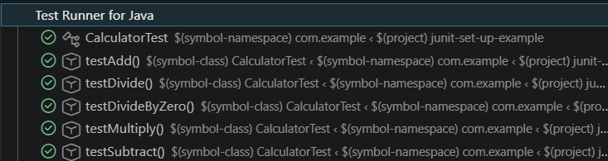

CONSOLE OUTPUT:

Setting up test...

Testing divide by zero

Cleaning up after test...

Setting up test...

Testing add method

Cleaning up after test...

Setting up test...

Testing subtract method

Cleaning up after test...

Setting up test...

Testing divide method

Cleaning up after test...

Setting up test...

Testing multiply method

Cleaning up after test…

EXERCISE 3:Assertions in JUnit

Code:
pom.xml

<?xml version="1.0" encoding="UTF-8"?>
<project xmlns="http://maven.apache.org/POM/4.0.0"
xmlns:xsi="http://www.w3.org/2001/XMLSchema-instance"
xsi:schemaLocation="http://maven.apache.org/POM/4.0.0
http://maven.apache.org/xsd/maven-4.0.0.xsd">
<modelVersion>4.0.0</modelVersion>

<groupId>com.example</groupId>
<artifactId>junit-assertions-example</artifactId>
<version>1.0-SNAPSHOT</version>

<properties>
<maven.compiler.source>11</maven.compiler.source>
<maven.compiler.target>11</maven.compiler.target>
</properties>

<dependencies>
<dependency>
<groupId>junit</groupId>
<artifactId>junit</artifactId>
<version>4.13.2</version>
<scope>test</scope>
</dependency>
</dependencies>
</project>

package com.example;

import org.junit.Test;
import static org.junit.Assert.*;

AssertionsTest.java

public class AssertionsTest {

@Test
public void testAssertions() {
// Assert equals
assertEquals(5, 2 + 3);

// Assert true
assertTrue(5 > 3);

// Assert false
assertFalse(5 < 3);

// Assert null
assertNull(null);

// Assert not null
assertNotNull(new Object());
}
}

OUTPUT:
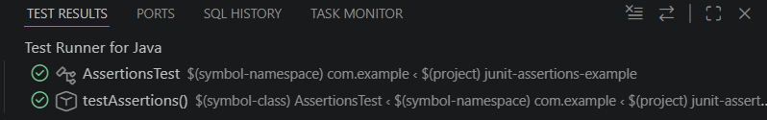

EXERCISE 4: AAA Pattern, Test Fixtures, Setup and Teardown Methods

Code:
pom.xml
<?xml version="1.0" encoding="UTF-8"?>
<project xmlns="http://maven.apache.org/POM/4.0.0"
xmlns:xsi="http://www.w3.org/2001/XMLSchema-instance"
xsi:schemaLocation="http://maven.apache.org/POM/4.0.0
http://maven.apache.org/xsd/maven-4.0.0.xsd">
<modelVersion>4.0.0</modelVersion>

<groupId>com.example</groupId>
<artifactId>junit-aaa-example</artifactId>
<version>1.0-SNAPSHOT</version>

<properties>
<maven.compiler.source>11</maven.compiler.source>
<maven.compiler.target>11</maven.compiler.target>
</properties>

<dependencies>
<dependency>
<groupId>junit</groupId>
<artifactId>junit</artifactId>
<version>4.13.2</version>
<scope>test</scope>
</dependency>
</dependencies>
</project>

Calculator.java
package com.example;

public class Calculator {

public int add(int a, int b) {
return a + b;
}

public int subtract(int a, int b) {
return a - b;
}

public int multiply(int a, int b) {
return a * b;
}

public int divide(int a, int b) {
if (b == 0) {
throw new IllegalArgumentException("Cannot divide by zero");
}
return a / b;
}
}

CalculatorTest.java
package com.example;

import org.junit.Before;
import org.junit.After;
import org.junit.Test;
import static org.junit.Assert.*;

public class CalculatorTest {

private Calculator calculator;

@Before
public void setUp() {
System.out.println("Setting up test fixtures...");
calculator = new Calculator();
}

@After
public void tearDown() {
System.out.println("Cleaning up after test...");
calculator = null;
}

@Test
public void testAdd() {
int a = 5;
int b = 3;
int expected = 8;
int actual = calculator.add(a, b);
assertEquals(expected, actual);
System.out.println("testAdd passed!");
}

@Test
public void testSubtract() {
int a = 10;
int b = 4;
int expected = 6;
int actual = calculator.subtract(a, b);
assertEquals(expected, actual);
System.out.println("testSubtract passed!");
}

@Test
public void testMultiply() {
int a = 6;
int b = 7;
int expected = 42;
int actual = calculator.multiply(a, b);
assertEquals(expected, actual);
System.out.println("testMultiply passed!");
}

@Test
public void testDivide() {
int a = 15;
int b = 3;
int expected = 5;
int actual = calculator.divide(a, b);
assertEquals(expected, actual);
System.out.println("testDivide passed!");
}

@Test(expected = IllegalArgumentException.class)
public void testDivideByZero() {
int a = 10;
int b = 0;
calculator.divide(a, b);
System.out.println("testDivideByZero passed!");
}
}

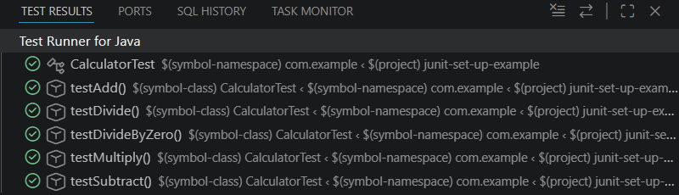
CONSOLE OUTPUT:

Setting up test fixtures...

Cleaning up after test...

Setting up test fixtures...

testAdd passed!

Cleaning up after test...

Setting up test fixtures...

testSubtract passed!

Cleaning up after test...

Setting up test fixtures...

testDivide passed!

Cleaning up after test...

Setting up test fixtures...

testMultiply passed!

Cleaning up after test...
MOCKITO EXERCISES:
EXERCISE 1:Mocking and Stubbing

pom.xml
<?xml version="1.0" encoding="UTF-8"?>
<project xmlns="http://maven.apache.org/POM/4.0.0"
xmlns:xsi="http://www.w3.org/2001/XMLSchema-instance"
xsi:schemaLocation="http://maven.apache.org/POM/4.0.0
http://maven.apache.org/xsd/maven-4.0.0.xsd">
<modelVersion>4.0.0</modelVersion>

<groupId>com.example</groupId>
<artifactId>mockito-example</artifactId>
<version>1.0-SNAPSHOT</version>

<properties>
<maven.compiler.source>11</maven.compiler.source>
<maven.compiler.target>11</maven.compiler.target>
</properties>

<dependencies>
<dependency>
<groupId>junit</groupId>
<artifactId>junit</artifactId>
<version>4.13.2</version>
<scope>test</scope>
</dependency>
<dependency>
<groupId>org.mockito</groupId>
<artifactId>mockito-core</artifactId>
<version>4.11.0</version>
<scope>test</scope>
</dependency>
</dependencies>
</project>

ExternalApi.java
package com.example;

public interface ExternalApi {
String getData();
int getStatusCode();
}

MyService.java
package com.example;

public class MyService {
private ExternalApi externalApi;

public MyService(ExternalApi externalApi) {
this.externalApi = externalApi;
}

public String fetchData() {
return externalApi.getData();
}

public int getStatus() {
return externalApi.getStatusCode();
}
}

MyServiceTest.java
package com.example;

import org.junit.Test;
import org.junit.Before;
import static org.junit.Assert.*;
import static org.mockito.Mockito.*;

public class MyServiceTest {

private ExternalApi mockApi;
private MyService service;

@Before
public void setUp() {
mockApi = mock(ExternalApi.class);
service = new MyService(mockApi);
}

@Test
public void testFetchData() {
when(mockApi.getData()).thenReturn("Mock Data");
String result = service.fetchData();
assertEquals("Mock Data", result);
verify(mockApi, times(1)).getData();
}

@Test
public void testGetStatus() {
when(mockApi.getStatusCode()).thenReturn(200);
int status = service.getStatus();
assertEquals(200, status);
verify(mockApi, times(1)).getStatusCode();
}

@Test
public void testFetchDataMultipleStubs() {
when(mockApi.getData()).thenReturn("First Call", "Second Call");
assertEquals("First Call", service.fetchData());
assertEquals("Second Call", service.fetchData());
}

@Test
public void testFetchDataWithException() {
when(mockApi.getData()).thenThrow(new RuntimeException("API Error"));
try {
service.fetchData();
fail("Expected exception was not thrown");
} catch (RuntimeException e) {
assertEquals("API Error", e.getMessage());
}
}
}

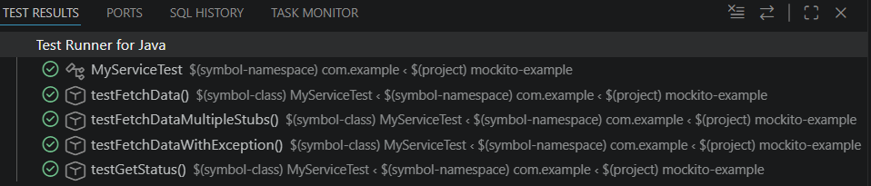
OUTPUT:
testFetchData passed!
testGetStatus passed!
testFetchDataMultipleStubs passed!
testFetchDataWithException passed!

EXERCISE 2:Verifying Interactions

Code:
pom.xml

<?xml version="1.0" encoding="UTF-8"?>

<project xmlns="http://maven.apache.org/POM/4.0.0"

xmlns:xsi="http://www.w3.org/2001/XMLSchema-instance"

xsi:schemaLocation="http://maven.apache.org/POM/4.0.0

http://maven.apache.org/xsd/maven-4.0.0.xsd">

<modelVersion>4.0.0</modelVersion>

<groupId>com.example</groupId>

<artifactId>mockito-verify-example</artifactId>

<version>1.0-SNAPSHOT</version>

<properties>

<maven.compiler.source>11</maven.compiler.source>

<maven.compiler.target>11</maven.compiler.target>

</properties>

<dependencies>

<dependency>

<groupId>junit</groupId>

<artifactId>junit</artifactId>

<version>4.13.2</version>

<scope>test</scope>

</dependency>

<dependency>

<groupId>org.mockito</groupId>

<artifactId>mockito-core</artifactId>

<version>4.11.0</version>

<scope>test</scope>

</dependency>

</dependencies>

</project>

ExternalApi.java
package com.example;

public interface ExternalApi {
String getData();
String getDataById(int id);
String getDataByName(String name);
void saveData(String data);
void updateData(int id, String data);
}

MyService.java

package com.example;

public class MyService {

private ExternalApi externalApi;

public MyService(ExternalApi externalApi) {

this.externalApi = externalApi;

}

public String fetchData() {

return externalApi.getData();

}

public String fetchDataById(int id) {

return externalApi.getDataById(id);

}

public String fetchDataByName(String name) {

return externalApi.getDataByName(name);

}

public void save(String data) {

externalApi.saveData(data);

}

public void update(int id, String data) {

externalApi.updateData(id, data);

}

}

MyServiceTest.java
package com.example;

import org.junit.Test;
import org.junit.Before;
import static org.junit.Assert.*;
import static org.mockito.Mockito.*;

public class MyServiceTest {

private ExternalApi mockApi;
private MyService service;

@Before
public void setUp() {
mockApi = mock(ExternalApi.class);
service = new MyService(mockApi);
}

@Test
public void testVerifyGetData() {
service.fetchData();
verify(mockApi).getData();
System.out.println("testVerifyGetData passed!");
}

@Test
public void testVerifyGetDataWithSpecificArgument() {
service.fetchDataById(5);
verify(mockApi).getDataById(5);
System.out.println("testVerifyGetDataWithSpecificArgument passed!");
}

@Test
public void testVerifyGetDataWithStringArgument() {
service.fetchDataByName("John");
verify(mockApi).getDataByName("John");
System.out.println("testVerifyGetDataWithStringArgument passed!");
}

@Test
public void testVerifySaveData() {
service.save("Test Data");
verify(mockApi).saveData("Test Data");
System.out.println("testVerifySaveData passed!");
}

@Test
public void testVerifyUpdateData() {
service.update(10, "Updated Data");
verify(mockApi).updateData(10, "Updated Data");
System.out.println("testVerifyUpdateData passed!");
}

@Test
public void testVerifyMultipleInteractions() {
service.fetchDataById(1);
service.fetchDataById(2);
service.fetchDataById(3);

verify(mockApi, times(3)).getDataById(anyInt());
System.out.println("testVerifyMultipleInteractions passed!");
}

@Test
public void testVerifyWithAnyMatcher() {
service.fetchDataByName("Alice");
verify(mockApi).getDataByName(anyString());
System.out.println("testVerifyWithAnyMatcher passed!");
}

@Test
public void testVerifyNoInteraction() {
verifyNoInteractions(mockApi);
System.out.println("testVerifyNoInteraction passed!");
}
}

OUTPUT:
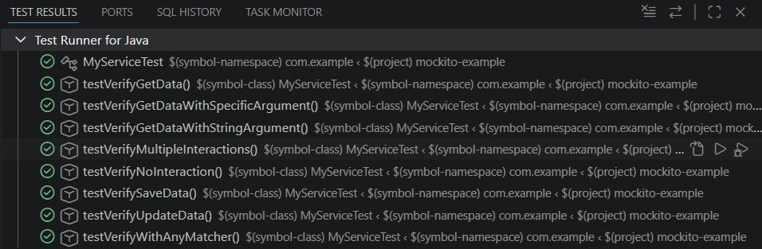

testVerifyWithAnyMatcher passed!

testVerifyNoInteraction passed!

testVerifyGetDataWithStringArgument passed!

testVerifyGetDataWithSpecificArgument passed!

testVerifySaveData passed!

testVerifyUpdateData passed!

testVerifyMultipleInteractions passed!

testVerifyGetData passed!

